Log Book | Group 2
Datasheets
LTL-4221N
ZTX458
74HC585N
74LS04N
74LS138N
TMP35
ALS-PT243
WEEK 2 - January 16 - January 22, 2022
PATTERN A
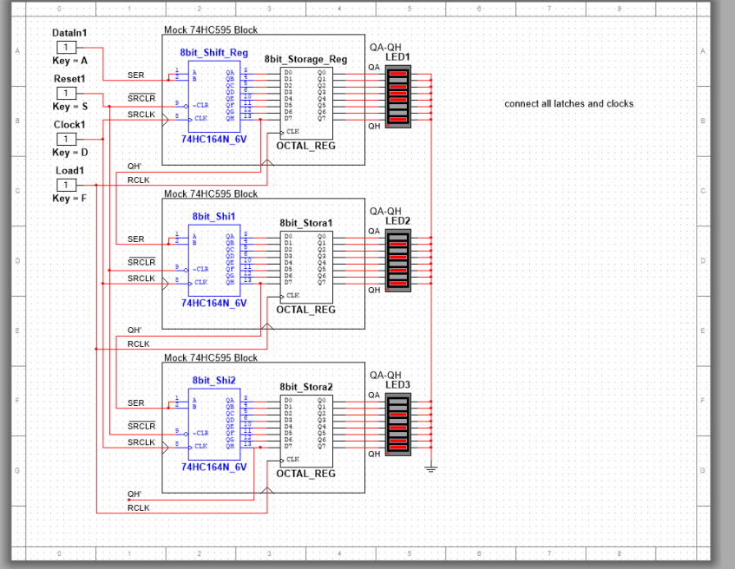
PATTERN B
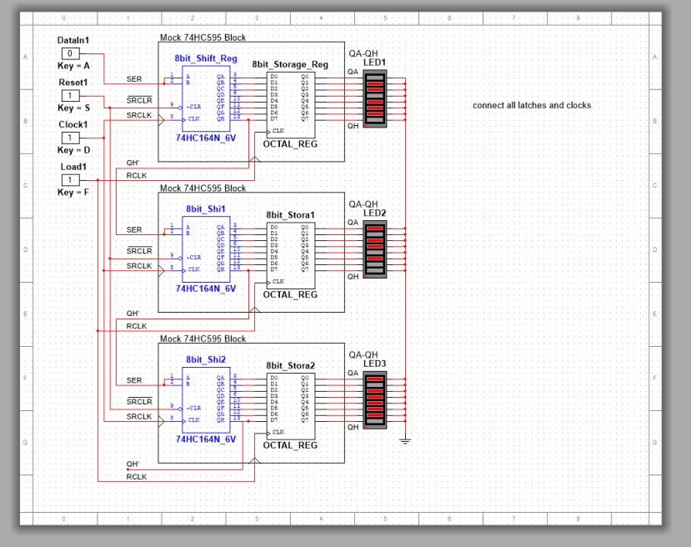
TIMING DIAGRAMS
ROW CONTROL CIRCUIT (Had issues)
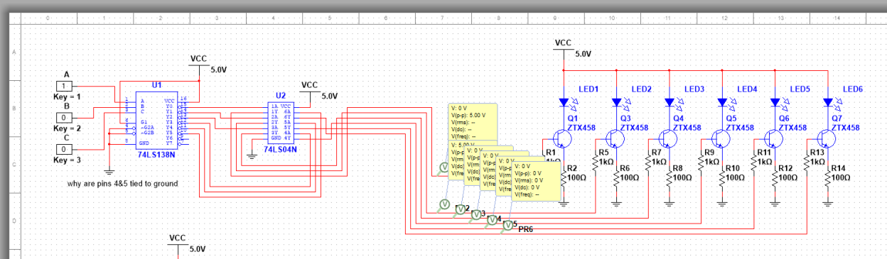
For some reason, despite the transistors getting 5V the LEDs would not turn on. Despite this issue we are confident that this circuit would work if applied.

Can you still produce the designated LED pattern?
When we discussed this, we both agreed that you could sort of. Although you couldn’t display the pattern ESE at once, due to the refresh rate of the human eye and the speed at which you can turn on and off the individual LEDS we theorized that you could most likely trick the brain into perceiving the pattern as desired with some clever programming of the display.

Week 3 - January 23 - January 29, 2022

For the row control our original plan was to have a 2-D array holding all the information of the ESE! output but we found that approach to be too inefficient, after brainstorming and taking another look at the pattern we noticed that some of the rows had the same pattern and that instead of storing information for 6 different rows we only need to store 3 unique row patterns.
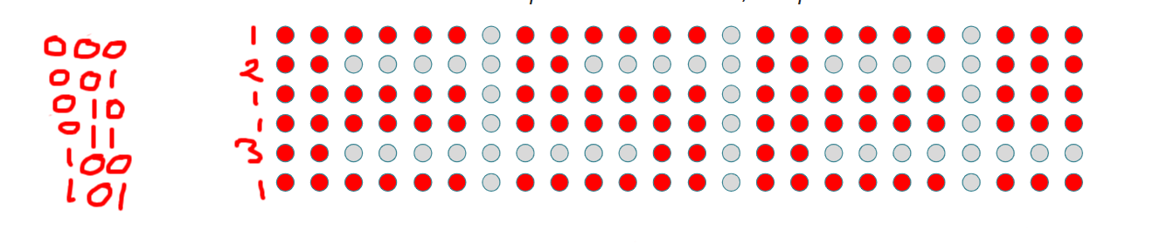

Week 4 - January 30 - February 05, 2022

1. takes text input
2. calculates length of array (6 per letter/number, 2 per punctuation, 1 space between each character)
- Will need to be able to tell the difference between a normal character and a punctuation
3. combines premade arrays of the corresponding characters into the “master” array
4. array is printed row by row and if needed the text is scrolled

Week 5 - February 06 - February 12, 2022

Sudo code for making the array for the string
String = “random words”
for (string.length){
If (string[i] == any letter/number){ //possibly use spaces
Array length +=7
Else if (string[i] == ./!){
Array length +=3
}
Boolean marquee[6][array length] = 0;

Display showing the string ABC!
Prototyped LED brightness with PWM. Sample code under week 5 drop box.

Week 6
Research vectors as a possible replacement for the master array as they have an unlimited space
Began prototype of automatic LED brightness adjustment by ambient light.
Presentation prepared.

Week 9 - March 06 - March 12, 2022
Brendan's notes:
Since we got the Temp35’s on Friday code was not prepared. Due to forgetting the multimeter at home I was unable to figure out which pins went where on the Arduino. I think I figured out the correct pins to the board and adapting the code I have for the different temp 35 I have at home will be no problem.
The temp rolling display is not completed but it will be easy to do once the hardware is sorted out. Simply put it into a string and put that into our array builder.

We were uncertain of what the hand analysis meant and attempted to come up with a formula to calculate what the output would be based off the lesson. Despite our efforts we haven't seemed to get it right and at this point it is unclear if it is an issue with multism or the mathematics preformed.
Overall, the temperature sensors will now be able to be implemented easily since I now have it at home. The goals for this week are not met but the foundations and all the ‘hard’ work is done. It is more about tweaking our current programs and hardware.
Week 10 - March 13 - March 19, 2022

Lumens are a measure of the total amount of visible light to the human eye from a light source. The higher the lumen rating the “brighter” the light will appear. Based on the following graph from the ALS-PT243 data sheet, the sensor has a sensitivity of 2x10⁻⁴mA/Lux
 | Lumens | Current | Config 1 | Config 2
Daytime | 98 000 lux | 19.6mA | 19.6V | 196V
Nighttime | 0.3 Lux | 0.06uA | 0.06mV | 0.6mV
Dusk/Dawn | 400 Lux | 0.08mA | 0.08V | 0.8V

What are the performance differences between the two
configurations?
The second configuration is 10 times more sensitive than the first as a change of 100Lux causes a voltage change of 0.02V in the first configuration, and a change of 0.2V in the second configuration
Given the application environment (in-lab), which
configuration do you think is more suitable? Why?
In the lab where the total range in the change In Lux is not that large, a more sensitive reading would be ideal, which is why I think the second configuration would be more suitable.
This diagram if for reference on the pin orientation.
With the code 5TempLightThing.ino (names a work in progress) the data is recorded into integer values and displayed. Integrating this code into our main program won’t be a problem the integer's just need to be converted to a string with F or C added depending on how we wish to display them on the rolling display.
Adjusting the brightness will be simple I just need to do some trial runs to determine the rough brightness of the LED to the sensor ratio. The brightness will adjust the same as it does in the previous week it just will not be a steady change.

Week 11 - March 20 - March 26, 2022
A helpful website was found for deciding which resistors to use and to help with understanding. https://www.physics.unlv.edu/~bill/PHYS483/op-amps.pdf
LED brightness was programmed and is now in the testing phase. It should be able to be implemented soon.
Gain is equal to (from the multisim schematic) R7=R8, R5=R6, Gain=R7/R5
We chose a gain of 10v/v as it is an even number that is easy to divide and should provide a good range. We went with Rf being 100k and r1 being 10k instead of 10k and 1k to make any variation in the resistors have less effect on the circuit.
For hand analysis we should get 10xthe input difference at the output with our gain.
Multisim simulation of Fahrenheit temperature sensor with amplification:
Amplification was breadboarded unsuccessfully. Another attempt will be made at a later date.

Week 12 - March 27 – April 2, 2022
The code has been reworked to be less demanding on the Arduinos dynamic memory by reworking the bank of premade letter matrices.
The op amp was created and proved to be pretty accurate. More measurements are needed before an exact real gain can be determined. Next week it is planned to combine all aspects into the final product. Everything is currently completed but it all need to be implemented into one system. Below are photos of the op amp circuit.

The yellow pins are input.
Green is –5v
Red is +5v
White is the output
The rest are data pins

